PROJECT NEWSLETTER 2

First short-term project partners' teams training event within The Music Balkan Train for Peace Project
Between 26th and 31st of August 2023 in Kochani, North Macedonia the first short-term project partners' teams of the project The Music Balkan Train for Peace took place.
During this period, 9 workshops were held on topics such as "Defining the framework of racism", "Phenomena of racism and radicalization", "The contribution of music to human rights, peace and European identity", and "Music as a tool for expression and education". Training experts from the NGO AID from Larissa, Greece, NGO LAG – Kochani, North Macedonia and Association Centre for Sustainability and Economic Growth (CSEG) from Pazardzhik, Bulgaria introduced and passed on their knowledge on the topics to all participants. A specially designed workshop on the work of John Lennon as one of the most outstanding examples of peace through music was also presented to the participants.
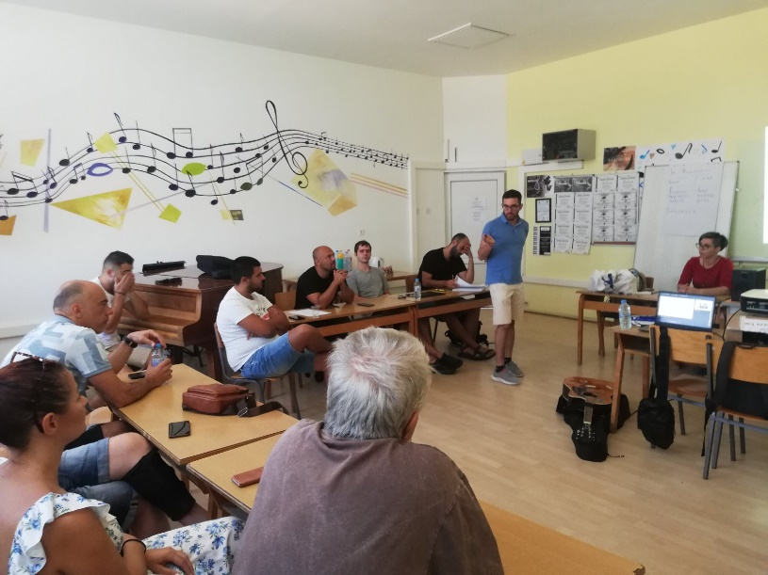
In addition to the workshops, the training also covered topics such as using the international learning platform eTwinning to exchange experiences between teachers from different countries, as well as Open Education Resources (OER), which allow teachers to teach in modern and attractive way.
In the last 2 days, mixed teacher teams also created a joint strategy to apply the knowledge gained from the training in their regular classes, preparations were made for the students' competitive event, and final discussions, evaluation of the activities and organizational details for the upcoming activities were also held.
The North Macedonian hosts had also organized a tour of Kochani and a traditional Macedonian dinner for their international partners, through which the guests could learn more about the local culture and their way of life and traditions.
Project “The Balkan Music Train for Peace” is implemented under the Erasmus+ Programme and aims to raise awareness and highlight the importance of peace and increase the sense of prosperity of students, their teachers and the school environment in general.
