PROJECT NEWSLETTER 3

Second transnational project partners meeting within the project “The Music Balkan Train for Peace”

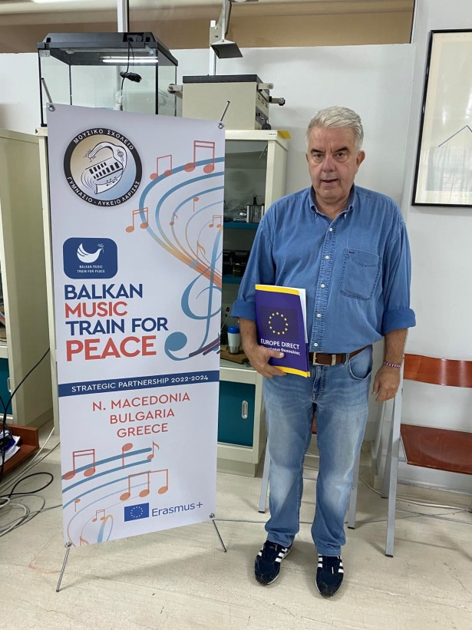
Second transnational partner meeting of the project “The Music Balkan Train for Peace” took place in the Greek city of Larissa. Despite the bad weather conditions in the area, the Music School of Larissa and NGO AID hosts ensured that all activities related to the meeting went smoothly and safely for the project partners.

During the working days(7-8-9 September 2023), the participants conducted several project-related sessions. Again, one of the most important topics was discussing approaches for implementing the training modules with the student's curriculum as well as providing feedback. The participating organizations prepared a plan for conducting the long-term teaching assignment with the students and also made a review and analysis of the Short-term training event in Kochani, North Macedonia, which took place between 26/08/23 and 31/08/23.
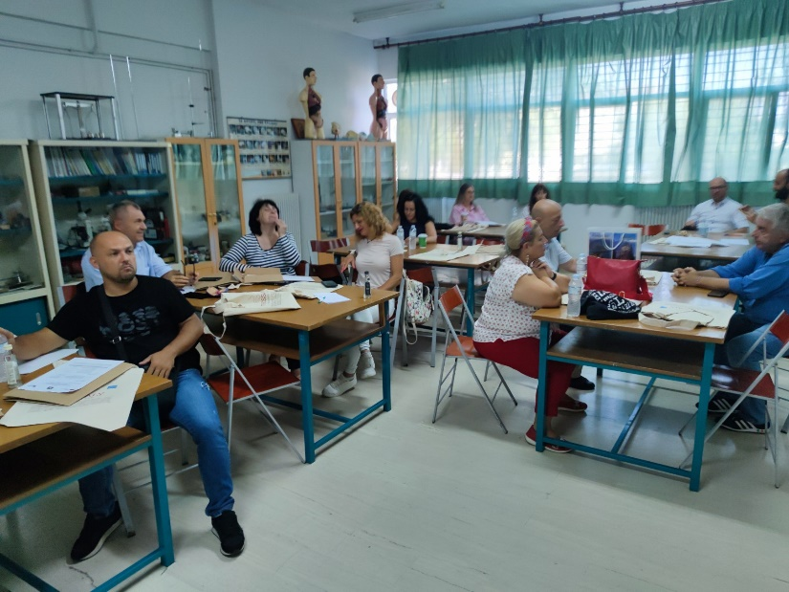

On the second day, there was a Steering committee meeting to set dates for the next project events, communication and dissemination activities, and First Progress Report – September 2023.

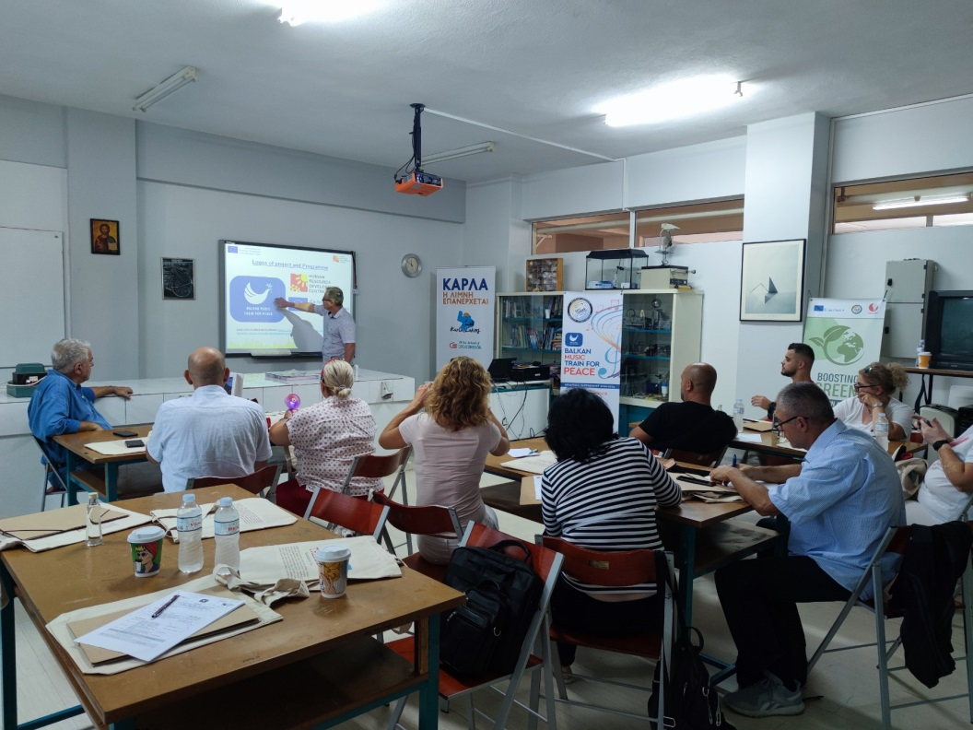
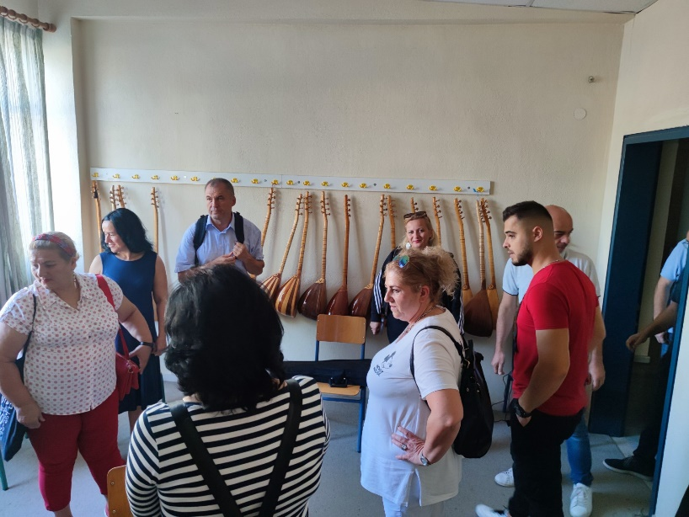
“The Music Balkan Train for Peace” project is implemented within the Erasmus+ programme and aims to raise awareness and highlight the importance of peace and increase the sense of prosperity among students, their teachers and the school environment in general.

